# CS 340 README Template

## Animal Shelter/About:

This project lists all the animals in the Austin Animal Shelter database and their details. In order to display those details, they are presented to you in a graphical user interface dashboard. This includes a data table with all the information, a geo location map, and a pie chart with percentage of breeds in the shelter. This system was built on MongoDB, Python, and Dash. MongoDB is chosen as it allows for easy database creation and management that can interact with python and other languages to create a clint-server interface for the user to interact with and use. Mongo allows this integration to occur easily and quickly as opposed to using pure SQL for these needs. Dash allows us to implement the graphical elements such as the datatable, the graph, and the map. This method allows for an easier implementation and usage of html practices to deliver a more readable and easier to use functionality for the end user.

## Motivation

This project was born out of the idea that the existing database and records was growing at a rapid pace and was no longer manageable or feasible to manage it under manual methods. In order for the records to be maintained accordingly, a new solution needed to exist in order to allow proper interaction and maintenance.

## Getting Started

In order to use this project for your own database management needs, your organization will need to perform a few requisite steps.

The sever or central machine running the database and interacting with it must have MongoDB installed on it. This project is a Python specific project and it is recommended to have Python 3.5 along with Anaconda and Jupyter setup on the machine.

## Installation

In Anaconda, configure the environment, for this project it is required to have Pymongo installed

In MongoDB, import your database into. Configure a user with Read/Write permission to access the database. Take note of the IP, Port, and Database name.

Configure Jupyter notebook to work with the Anaconda software.

Download the AnimalShelter.py and Main.ipynb files to the desktop of the machine connected to the database.

Upload both files to your Jupyter notebook.

Open the AnimalShelter.py File.

In Main.ipynb, replace username and password values with your username and password

## Usage

Upon running, a web interface should present itself and display all animals in the shelter in the data table.

The button swill allow you to filter dogs based on rescue/service needs. When clicking any of those buttons a find command runs that looks for the criteria of the selection such as breeds, age, and gender style. Those fields can easily be modified in Main to update the criteria if need be.

The datatable can be paged through to browse results.

### Code Example

Username/Password Update in Main

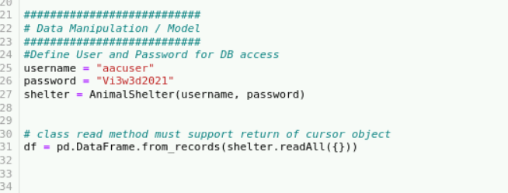

Code for declaring buttons

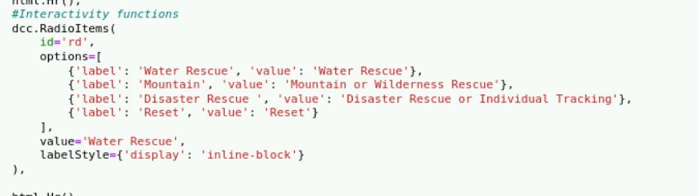

Set criteria for buttons

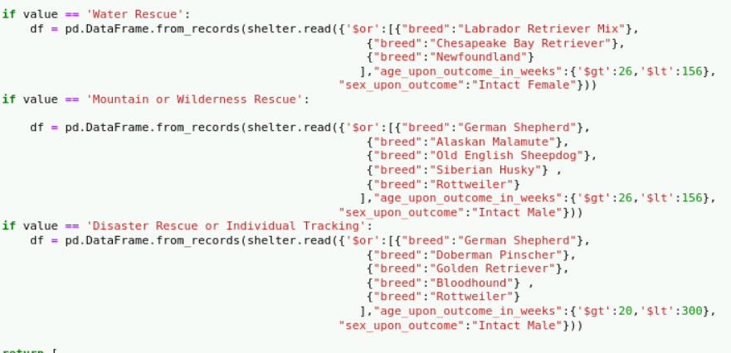

### Tests

In testing the application, we ran the application with a test database and achieved favorable results. The application pulls the database from MongoDB and reformats that information into a graphical interface for the user to be able to navigate and find the information they need.

### Screenshots

### 

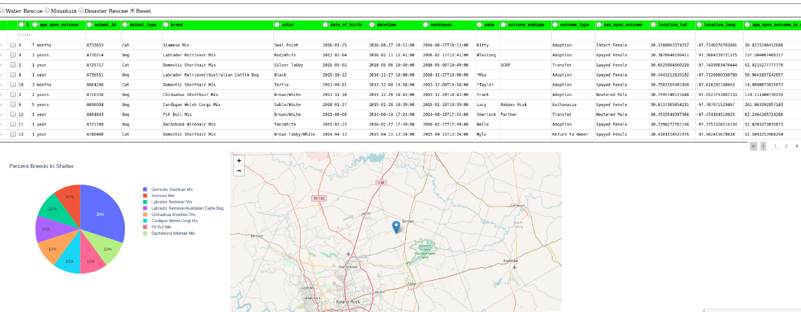

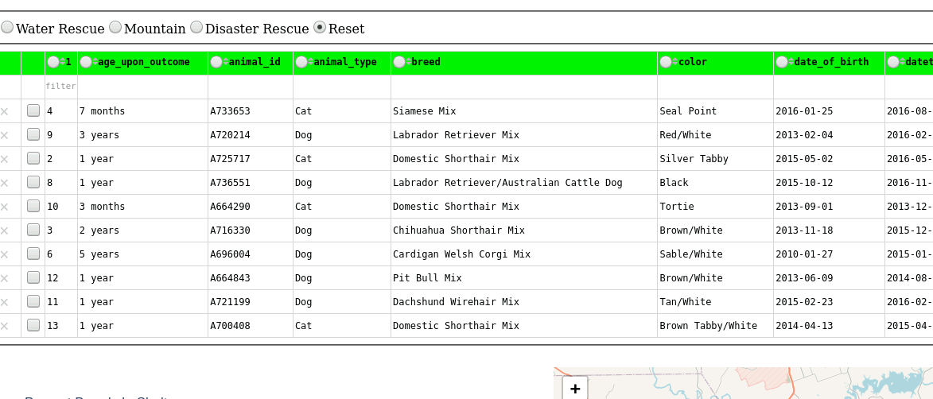

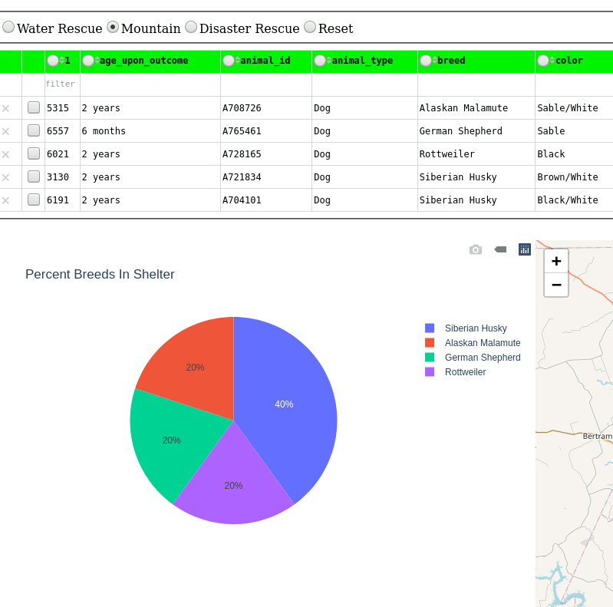

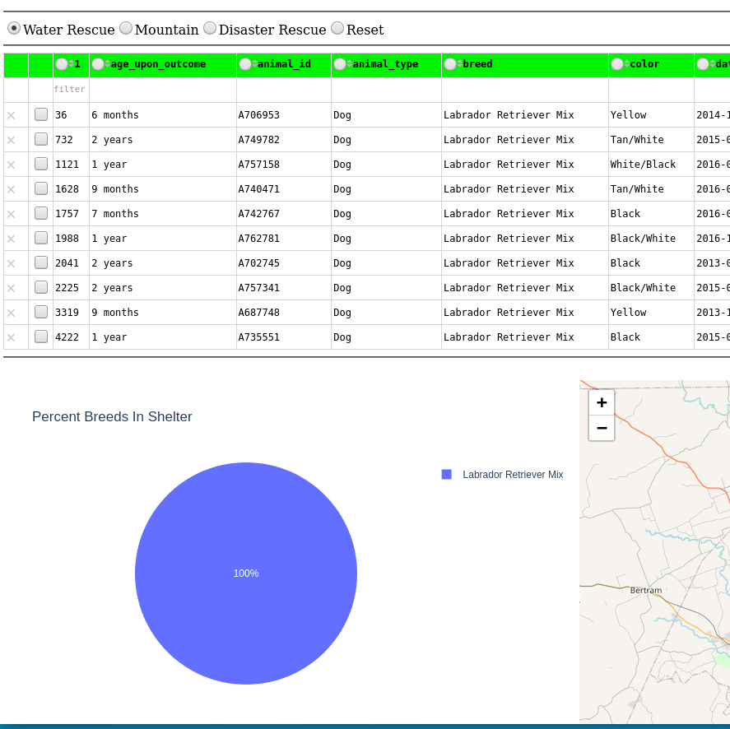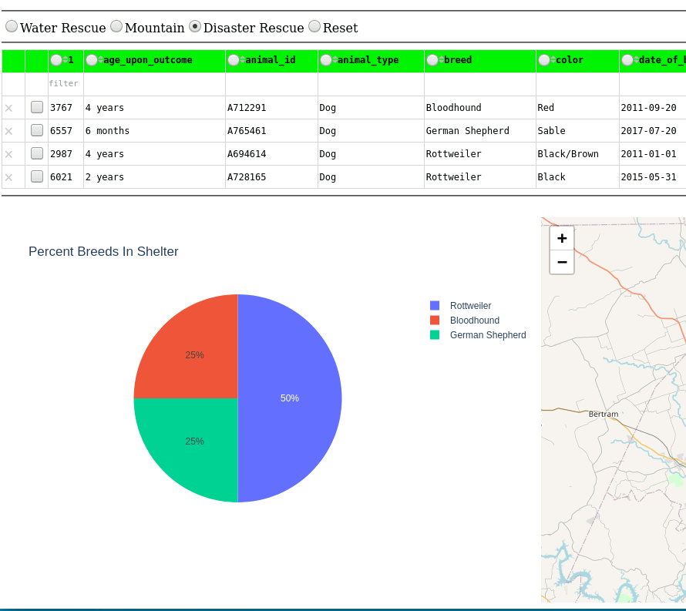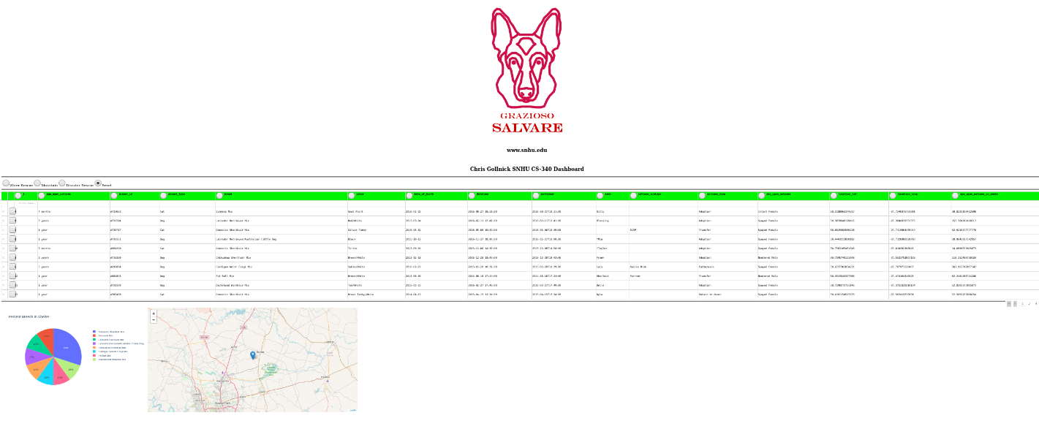

## Roadmap/Features (Optional)

Any future updates or altercations to the code need to be carefully examined and considered. While changing elements such as search criteria is relatively easy, calling a different query, implementing new graphs, or changing the overall look need to be adjusted in multiple areas. For example, changing the name of the datatable ID needs to be altered in various places in order for it to run proper. You may need to change the port and ip in the AnimalShelter.py file if the application is chosen to be hosted on a remote machine or server or if you choose to use a different configuration depending on the companies networking needs. Implementing for use in Jupyter is critical for the project to be used as is, but in theory the project can be migrated to a different IDE. In which case, it will become necessary to ensure the right pip installs are performed and both files may require new import lines to be added.

## Contact

Your name: Chris Gollnick